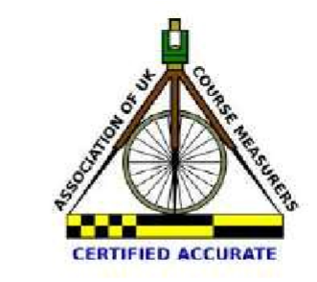
Certificate of Accuracy Number TBA Under UK Athletics Rules, Licence Number 2017 27863

Keswick Athletic Club

Round the Houses 5.3 Mile
Wednesday 19th April 2017
7pm start
A 5.3 mile circuit of Keswick from Fitz Park through the central square, up Manor Brow and back through the square for a return to Fitz park.

ENTRY ON THE DAY ONLY Registration from 5pm-6.55pm.
Registration, start and finish at Fitz Park cricket pavilion. Parking is available nearby.

Surname..............................................First Name...........................
Address.....................................................................................................................................................................................................Post code.......................................Contact number .......................
Date of Birth...............................Age on Race Day..........................
Gender: Male / Female (Please circle)
Club Name (if applicable)
.........................................................................................................
Declaration: I agree to abide by the rules of UK Athletics. I understand that I enter this race at my own risk and that no person(s) or organisation(s) will be held responsible for any accident, injury or loss to me prior to, during or after the event. I understand that the organisers reserve the right to alter arrangements/conditions should circumstances require. This information will be held in accordance with the Data Protection Act 1998 and will be used for the purposes of administration.

Signature....................................................................................................................................
Entry Fee: | Affiliated runners | £6
 | Non-affiliated runners | £8 Keswick AC runners £5
-----------------------------------------------------------------------------------------------------------------------------------------

Official Use only: Age/Gender Category

